SPriNG 2017 communique

A Note from league president amy jacksoN
hard at work
$52,000: Raised at the 2017 Every Child Matters Gala. These funds will support community projects in 2017-18.
125: Attended Community Summit 2017 to build resilient children and resilient communities.
836: Facebook followers of the Junior League of Olympia – that’s 47 percent growth in one calendar year. Like our page to stay in touch.

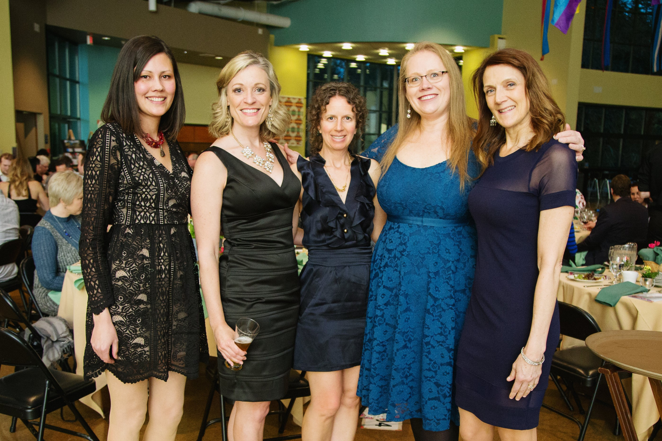
Our 2017 Every Child Matters Gala was enjoyed by 127 community and league members. KMW Photography

So long, farewell……………………….

The end of another league year is upon us. I can hardly believe it.
Someone recently asked me if I was glad to be handing over the reins to President-Elect Marianne McIntosh and I had conflicting thoughts on how to answer that question.
I’m so thankful that I was chosen to be president of the Junior League of Olympia.
I’m the type of person who doesn’t hesitate about decisions. When the opportunity came up to lead the Junior League of Olympia, I didn’t hesitate for more than two minutes, which is a long time for me to think things over.
It is an honor and a privilege to have filled this placement. Having not served on the Board of Directors before I became president-elect-elect, I had a steeper learning curve than some others before me. It was a job I took very seriously.
I describe the presidency placement to non-leaguers as being equal to the act of giving birth or perhaps running a marathon.
I’ve never run a marathon, but from what I’ve heard, birth is sort of similar.
When I was pregnant with Bodie, I read about birth, asked lots of questions of many different experts (doctors, friends who were moms and, of course, my own mother) and immersed myself in the entire experience. I trained like an athlete. But until you are in the act of labor you have no idea what’s in store for you physically or mentally.
I had a birth plan that was amended so many times and who knew I’d be in labor for three days? I had a doula who, in her defense, had no idea Bodie was so happy being in my belly he really didn’t want to see what the world had in store for him.
At the end of the third day, I was tired of pushing. I was ready to be done, but didn’t regret the experience for one single minute.
President’s Message continues on page 2…
Like labor, I’m tired, but so happy to have been on this journey. Also like labor, I haven’t been alone. I have had Marianne and Past-President Hannah McDonald, the other board members and AJLI to fall back on. Each of these three different components have been like that crazy trust exercise where if I fall and one of them is there to catch me.
President’s Message continued from page 1…
I understand why some leagues require the president’s placement be a two-year term. Many moms have told me the second birth is easier than the first. Their body is ready and knows what to expect, their husbands are more comfortable with the whole baby thing and the learning curve isn’t as steep. If we did a two-year placement for the presidency, all would be true.
So, I will always be thankful for this opportunity to serve the league and my community, but I am getting a bit tired. I’m ready to see the fruits of my labor, enjoy life more fully and not be caught up in the enormity of it all.
I’m excited to see what amazing things Marianne brings to us next year and President Elect-Elect Norma Cortez-Moreno after her. I am leaving you in the best of hands.
Thank you for the opportunity to serve as your president. It’s been a pleasure and an honor.
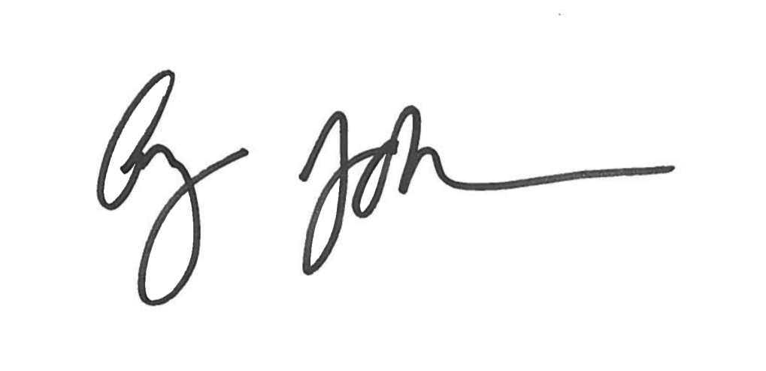Thank you to everyone who has helped me find abounding passion and fun this year. I hope you all find your own passion and have fun doing it!
Warmly, Amy Jackson

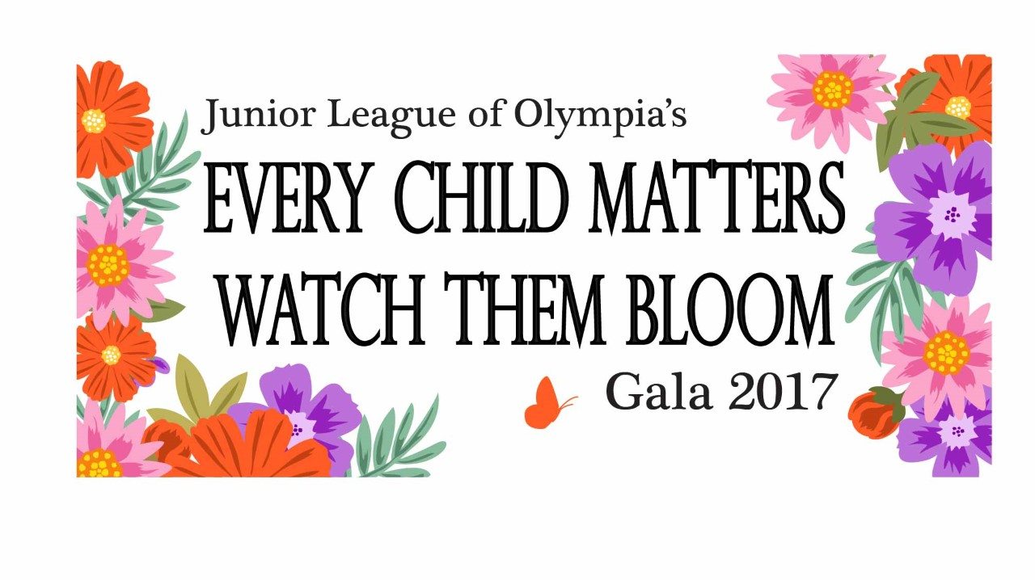
Gala 2017: every child matters, watch them bloom Recap
By Michelle Murphy, Gala Committee Chair
The Every Child Matters Gala and Auction 2017 was a great success!
The 127 guests at our blooming garden-themed event helped the Junior League of Olympia raise more than $52,000. More than $12,000 was raised during the Fund-a-Need paddle raise for the Tanglewilde Small Park project.
This year we had a new Golden Ticket raffle, which was enthusiastically received. All the tickets sold quickly and one lucky winner had her choice of taking home any live auction item before it went to bid. The Golden Ticket raffle will be included next year as well.
Congratulations to Marianne McIntosh for being the lucky winner of the Panowicz raffle and table captain Amy Jackson for hosting the most profitable table that night.
Local jazz musicians PC & J set the mood, and Jeff Evans the magician amazed and yes, even confused.
Auctioneer Cindy Schorno and emcee Laura Murphy kept the crowd lively throughout the live auction. Cindy is definitely on the top of the list for a repeat performance next year!
Finally, a huge thank you to the Gala Committee, Tawni Allen, Jeni Houghton, Jenifer Robertson, Lisa Ankerstjerne, Noriana Prior, Mandie Dell and Meghan Sapp for your tireless dedication and perseverance! And thanks a million to Kimberly Witort Photography for her generous donation of time and services taking such beautiful pictures of the event.

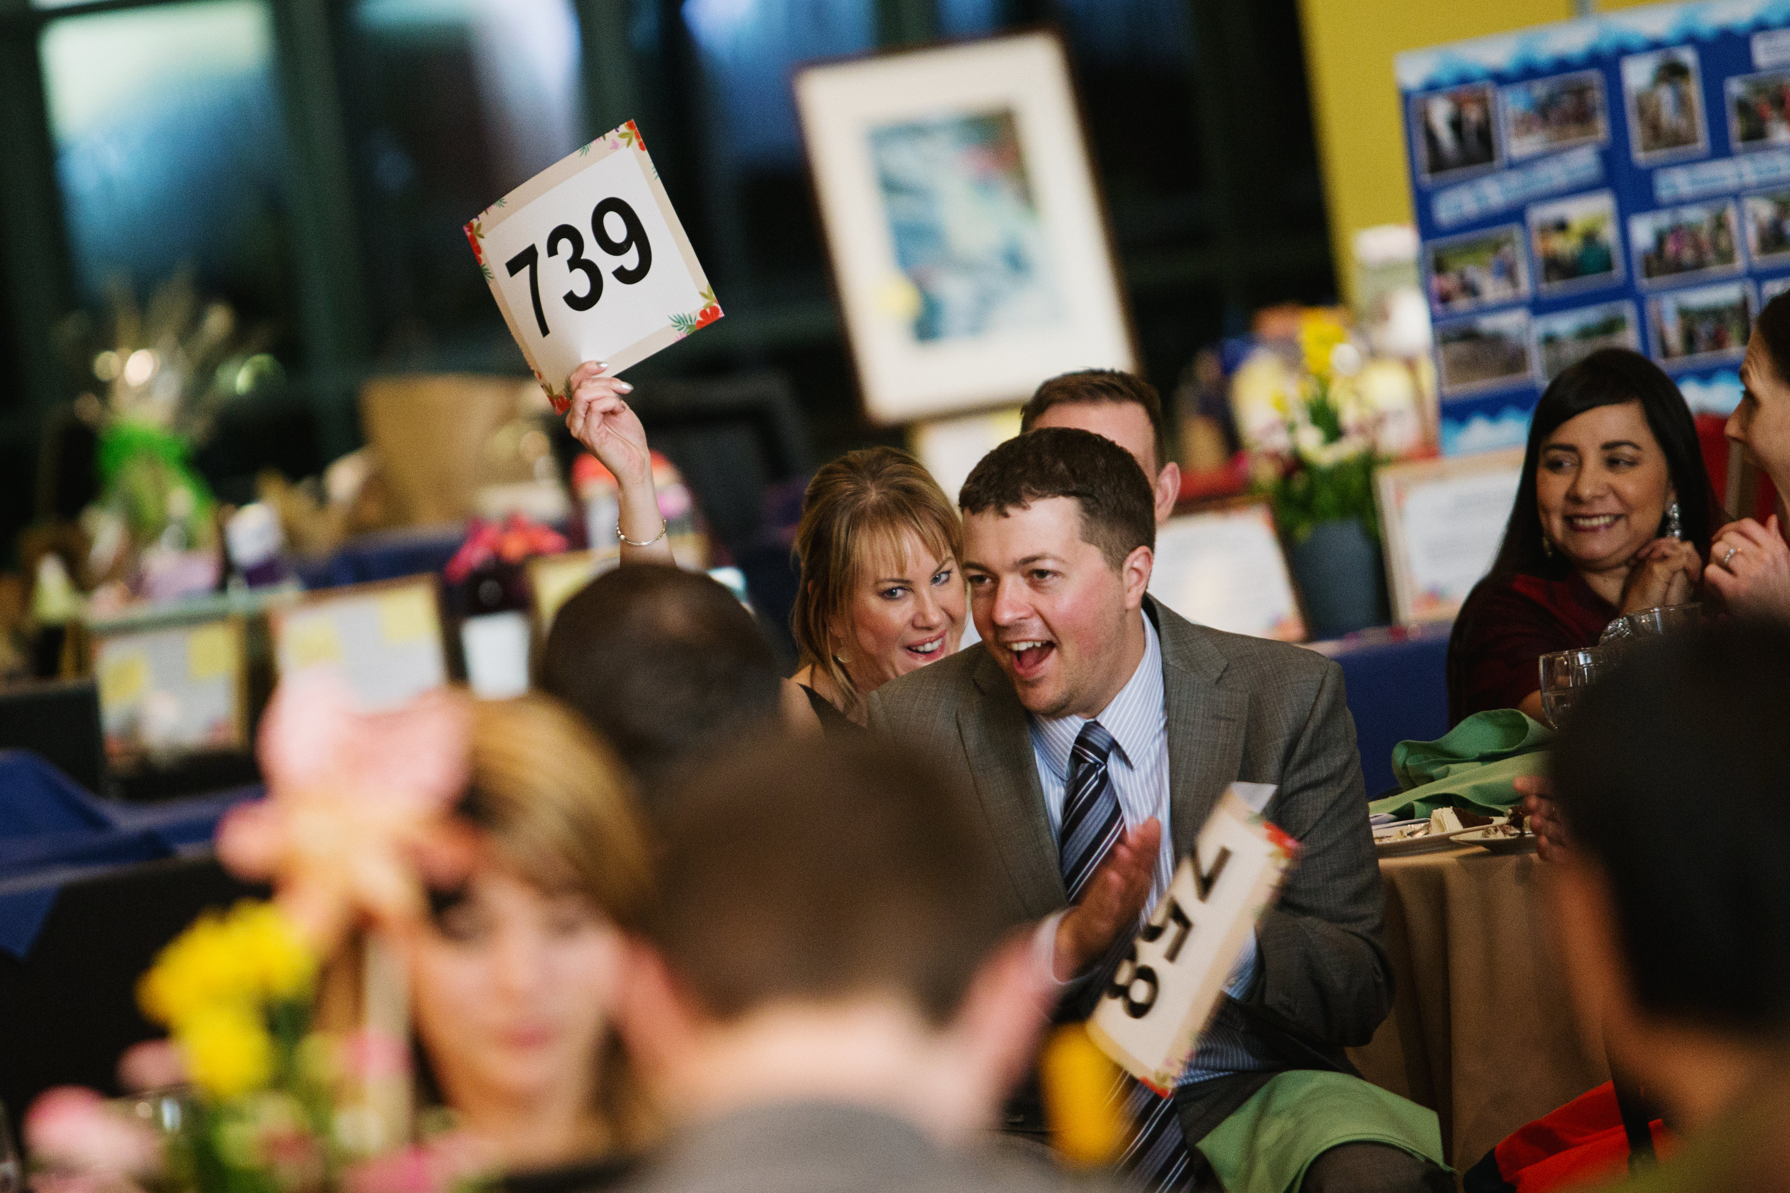
Gala 2017: every child matters, watch them bloom
Funds raised at the 2017 Every Child Matters Gala will support the Junior League’s community projects in 2017-18 with Little Red Schoolhouse, St. Peter Foundation, SafePlace, Monarch Children’s Advocacy and Justice Center and the Child Care Action Council. KMW Photography

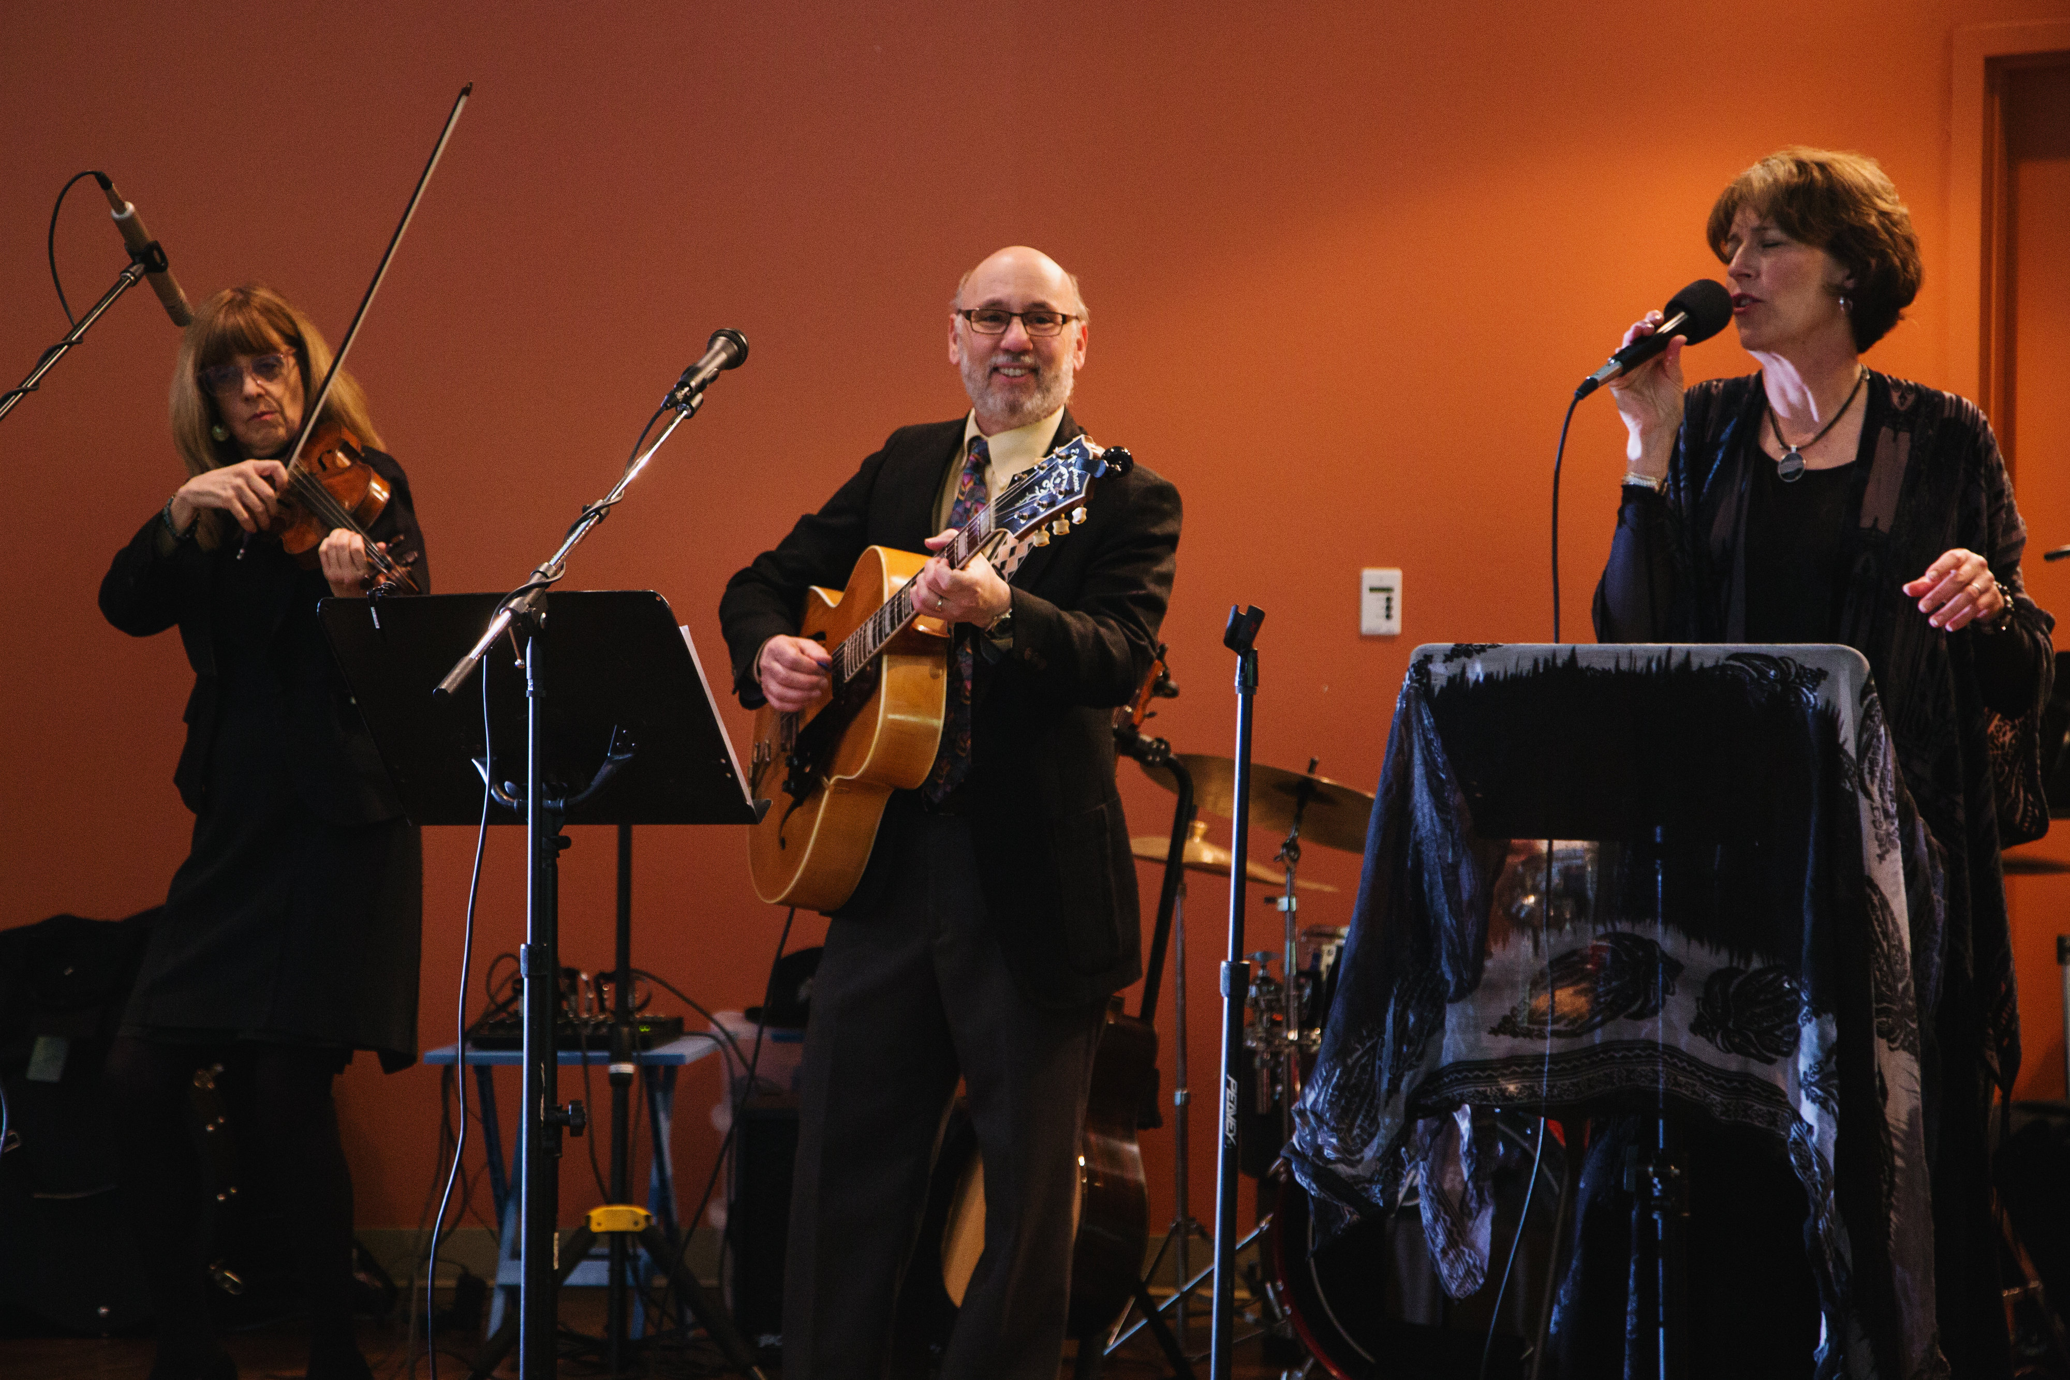
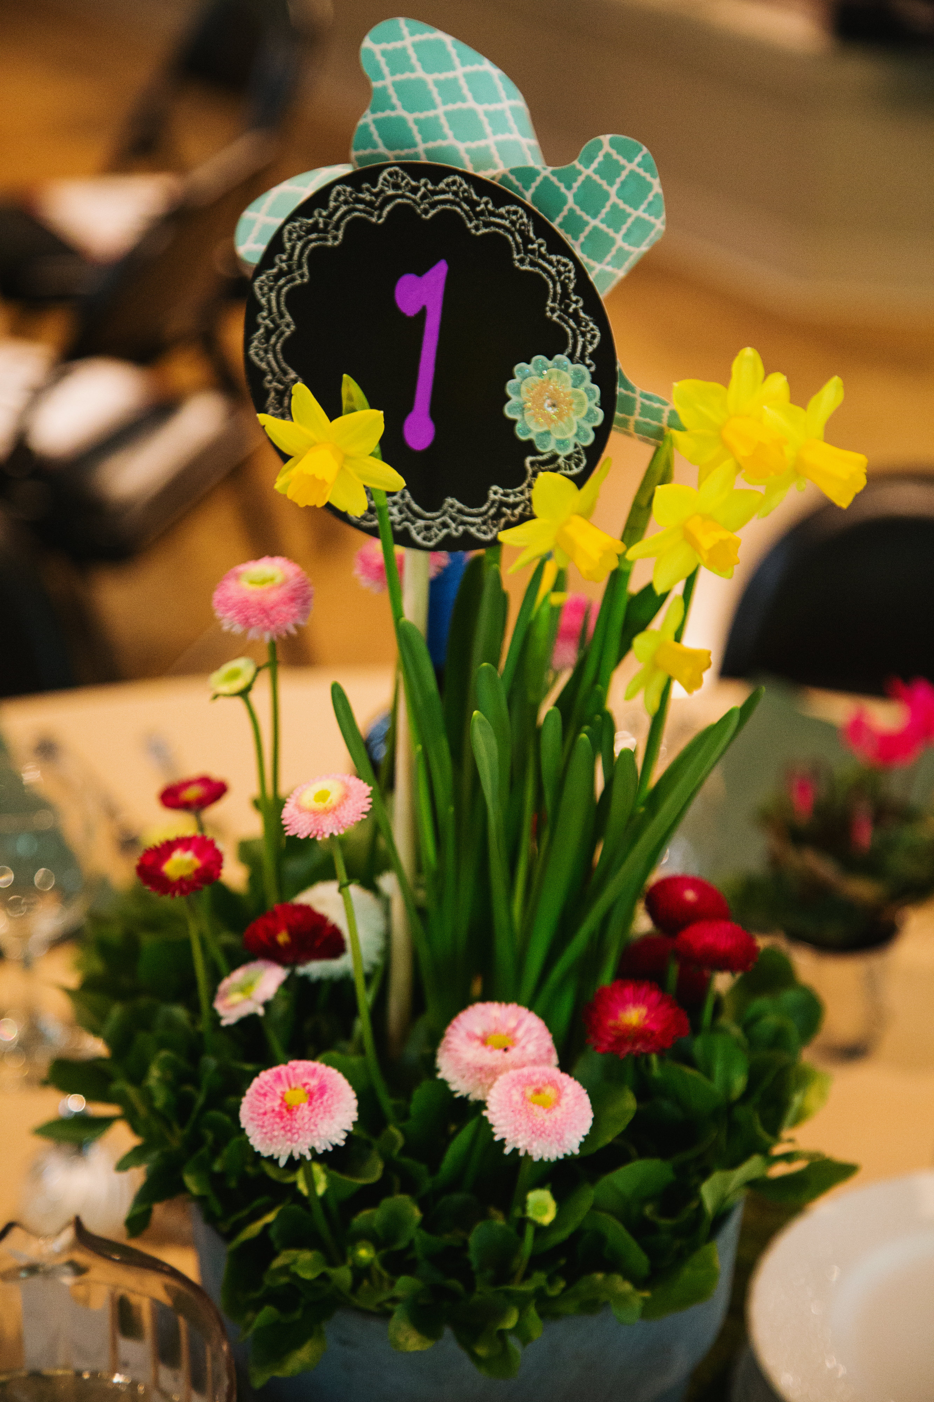
(Left) 2017’s gala was in full bloom with beautiful potted flowers on each table. Guests even got to take home potted flowers as party favors. (Right) Jazz trio
PC & J kept guests entertained and set the mood during the silent auction and dinner portions of the evening. KMW Photography
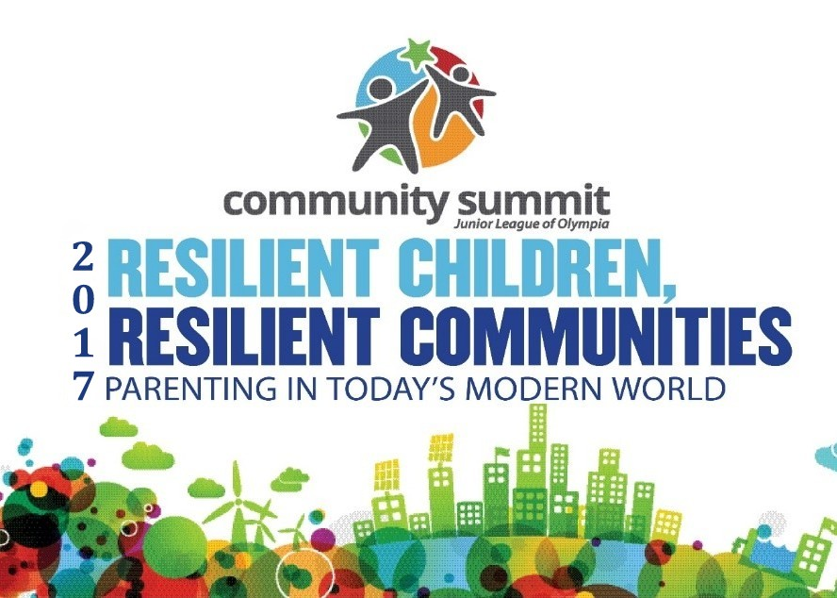crowd of 125 participate in fifth annual community summit event
By Jessi Doerpinghaus, Community Summit Chair
The Junior League of Olympia hosted its fourth Annual Community Summit on Resilient Children, Resilient Communities on Feb. 25.
The event supports the league’s focus area of preventing child abuse and neglect in Thurston County. Through parenting education and community conversation, league members and the community developed ideas to provide services to foster resiliency in children and parents.
More than 125 attendees were treated to a day of parenting workshops, access to valuable community services and conversation.
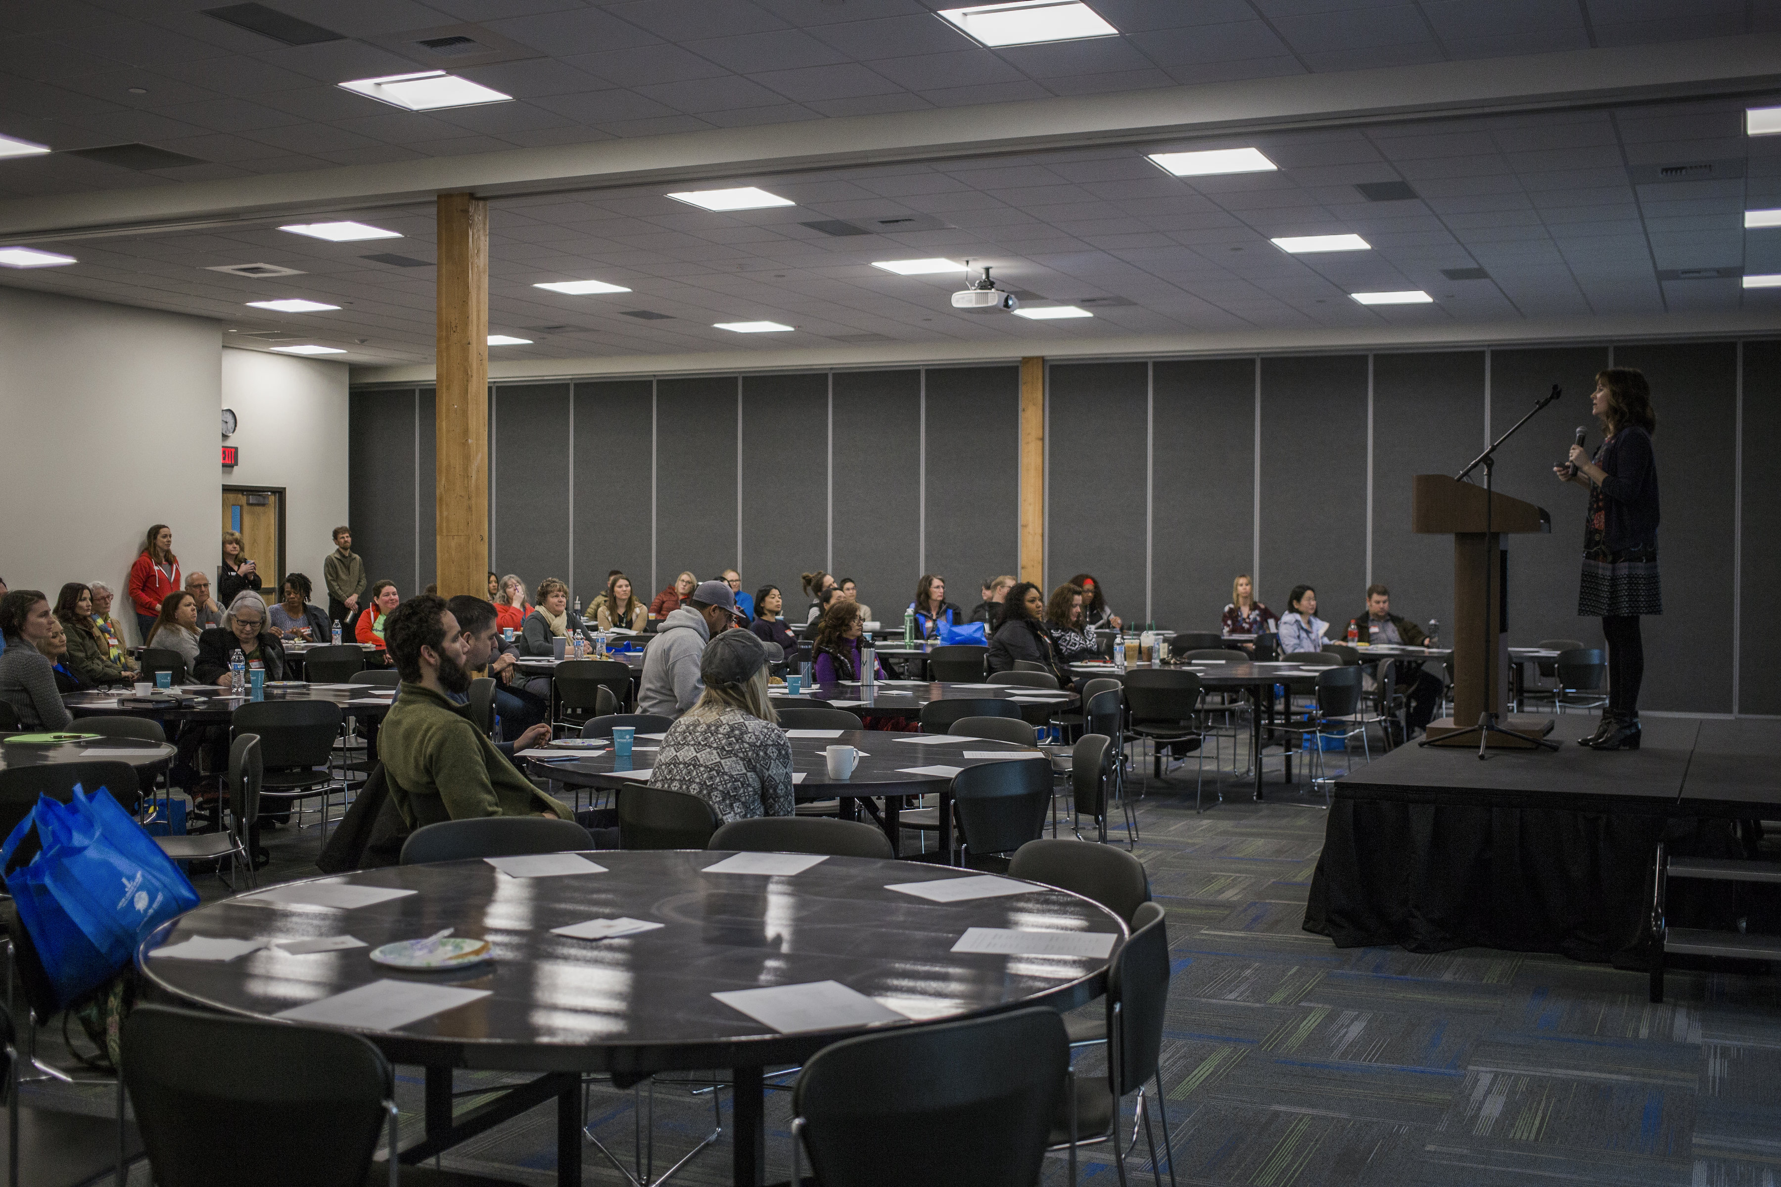
Parenting coach and blogger Emily McMason of Evolving Parents provided the keynote address called All of Parenting Happens on the In-Breath.
Following the keynote, attendees participated in breakout sessions on topics ranging from the evolving role of fathers, co-parenting, how to manage anger and stress in the home, how to stop arguing with your teen or tween and resolving power struggles.
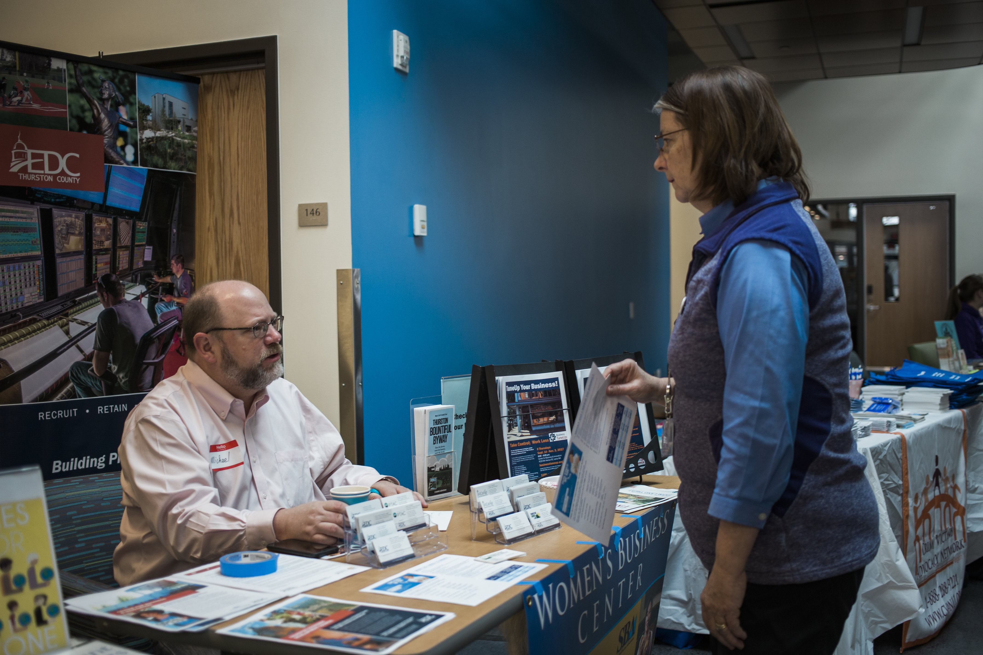
The day concluded with a community leaders panel discussion on family engagement and an interactive community conversation led by Liz Davis, a Junior League of Olympia sustainer mentor and Thurston Thrives’ community coordinator.
During the day, attendees attended a community resource fair. Thirty-one local organizations, including the South Sound Reading Foundation and the Child Care Action Council, were present to provide information on local resources available to all parents and children in the county.
The focus of Parenting in Today’s Modern World was a success thanks to supporting partners Thurston Thrives, Thurston County Economic Development Council, Family Education and Support Services and MIXX 96.1.
(Top) Evolving Parents Blogger Emily McMason was the keynote speaker at our 2017 Community Summit. (Bottom) Throughout the event, participants could access services from about 30 community partners like the Economic Development Center. Kayleigh Stefanko Photography
Be on the lookout for more information on the 2018 Community Summit on www.jlolympia.org/community-summit.

Junior league of Olympia board opportunities coming in 2017-18
By Alex Monroe, Placement, Nominating and Advisory Committee Chair-Elect
Governance, Strategy, Leadership. What do these words have in common?
They represent the responsibilities of our league’s Board of Directors.
Our Board of Directors is made up of an Executive Committee, elected by the membership, and the board-appointed positions of membership, funding, training and sustainer vice presidents.
The Executive Committee includes: president, president-elect, community VP and operations VP. The immediate past-president also serves on the board the year following her term as president.
Each year, members can apply to serve on the board. Your Placement, Nominating Advisory Committee is responsible for developing a slate of candidates for board openings throughout the year and present the nominees to the board and/or the membership for approval.
The 2016-2017 league year was a busy one with six board positions filled, including three executive committee positions that were voted on by the membership. Thankfully, there was a lot of interest from our membership in serving, with most positions garnering multiple applications!
Did you know the Junior League of Olympia’s board, as with other nonprofit boards, also has legal and fiduciary responsibilities?
These are often described as the duties of care, loyalty and obedience. These items translate to the exercise of reasonable care when making a decision as a steward of our organization, acting in the best interests of the league when making decisions for the membership, being faithful to our mission and acting in a way that is consistent with our central goals.
In addition to the responsibilities that come with a position on the board, there are also a number of rewards. Board members learn new skills, make new connections, collaborate with women across councils and leagues, effect change in our organization and community and have fun while making an impact.
The Placement, Advisory and Nominating Committee is gearing up for the next round of board nominations for the 2018-2019 and 2019-2020 league years.
Opening positions include:
*President-elect (to begin serving in January 2018, president-elect in 2018-2019 and president in 2019-2020)
*VP of operations (two-year term)
*VP of membership (two-year term)
*VP of training (two-year term)
*Sustainer VP (one-year term)
Are you interested in and committed to honing your leadership skills, helping set League direction, learning more about governance, and using your time and talents to further our mission?
Watch for more information about how to apply this fall. Don’t hesitate to reach out to current and past board members and your Placement, Advisory and Nominating Committee to learn more about the responsibilities and rewards of serving our league as a member of the board.
“The best way to find yourself is to lose yourself in the service of others.”
— Mahatma Gandhi
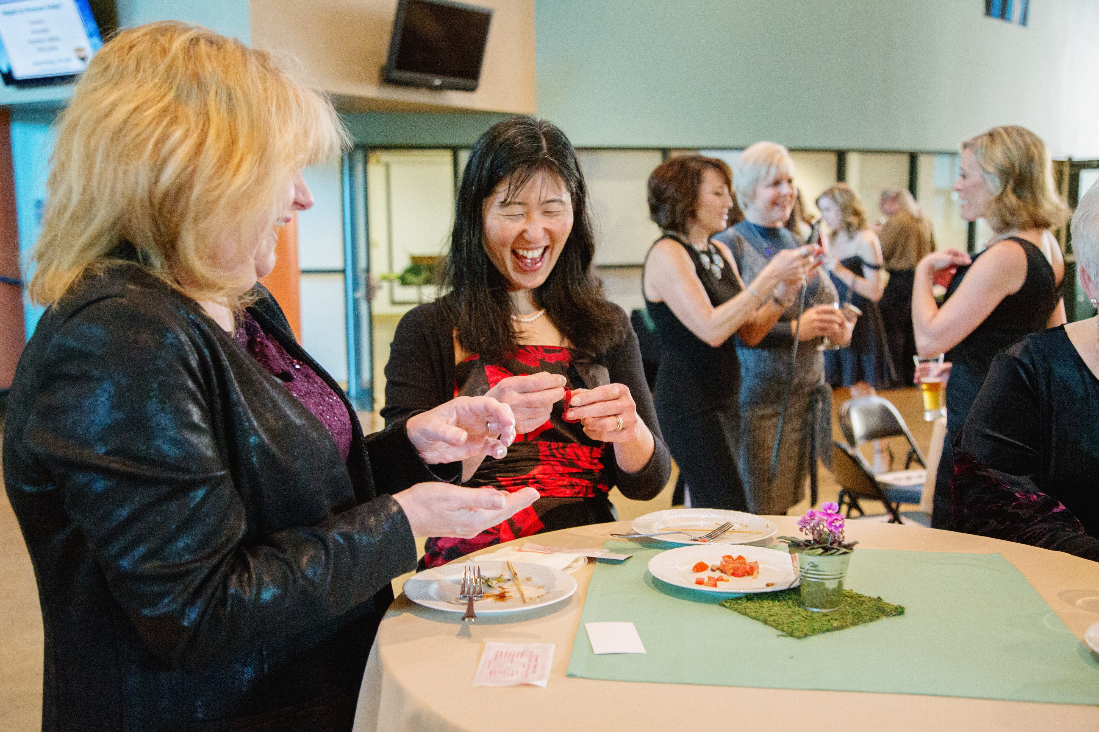
communications committee busy at work behind the scenes
By Jillian Henze, Communications Committee Chair
The work of the Communications Committee was fast and furious in February and March 2017 getting the word out about two of our biggest events of the year.
The team worked with the Community Summit Committee on marketing efforts that helped fill the event venue with more than 125 people.
Thank you Kimberly Witort for the gorgeous photos of our annual gala event. The Communications Committee members have brought valuable skills to the league this year including professional graphic design, photography, marketing, public relations and eblast expertise.
The day of Community Summit, multiple communications team members attended to provide live updates on Facebook, Twitter and Instagram. These social media efforts allowed those who couldn’t attend in person to participate, and helped promote the Junior League of Olympia brand to our community.
After the successful Community Summit, our team focused efforts on marketing the Every Child Matters Gala that had 127 attendees. Jeni Houghton, our gala liaison, designed and printed beautiful event collateral and booklets. Kimberly Witort on our committee took the gorgeous photos of the fundraiser.
These all-hands on deck events allowed our communications team to blossom. Team members really got into the flow of sharing the work. Many hands do make light work! This spring, we flexed our flexibility muscles to divide and conquer.
While learning to work well together, our committee members also learned more about the world of communications and marketing.
We toured the Washington Hospitality Association’s communications facilities at our March meeting. It was a fun field trip that expanded our knowledge and made connections in the community. It was led by David Faro, senior communications manager for the association and member of the Tanglewilde Park Center Board.
In March and April, our committee met and discussed a significant external branding opportunity – the upcoming 25th Anniversary Celebration. Team members are full of valuable, easy-to-implement ideas that will capitalize on our special anniversary to promote the league and better introduce ourselves to the community. The committee will continue working closely with the 25th Anniversary Committee throughout the summer to help kick things off right.
Now, we’re at a point of transition. We’re making notes for next year and training our chair-elect, Katie Stamwitz, who will be a strong leader in 2017-18. This will be Katie’s third year on the committee and her knowledge and experience will be a true asset to the league.
Your communications team will keep working throughout the summer to prepare for the fun year ahead. So, don’t worry – we’ll keep in touch!

Changing of the guard: Marianne Mcintosh is the 2017-18 Junior league of Olympia president
By Marianne McIntosh, President-Elect
The gavel has been passed. My presidential year has arrived. Wow! I’m stunned and amazed how quickly time flies by.
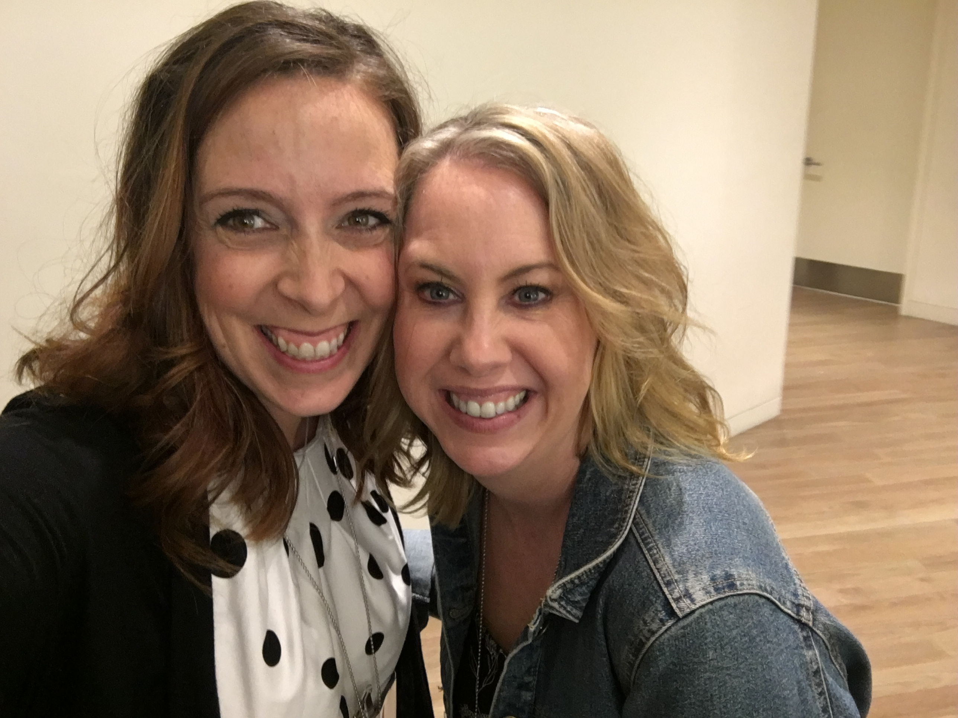
More than 12 years ago, I discovered the Junior League of Olympia through a brochure tucked into a Deck the Halls basket.
I read through the brochure and was immediately intrigued. I reviewed the league’s website, which detailed the its community impact as well as the bonds formed between the members.
I wanted to give back to my community and meet new friends.
Once I contacted the league, I was invited to attend a general membership meeting at the Olympia Yacht Club. Michelle Green, membership chair, welcomed me at the meeting and I eagerly joined that night.
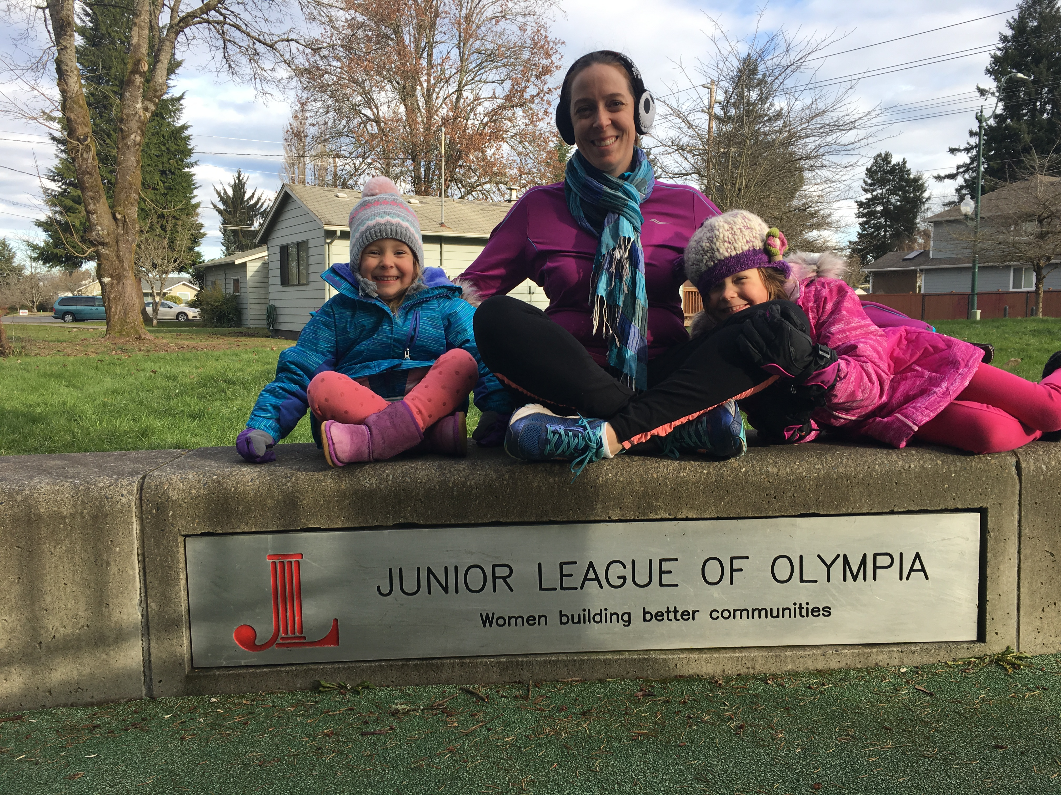
I’ve been a committee member, chair and board member at various points throughout the past 12 years. I went from active to sustainer back to active.
Most of my placements have been in the Funding and Operations councils. Throughout my placements, I learned many skills that benefited my league experiences and life outside of league. I also connected with many women who were there for me through pregnancies, job promotions, raising two little girls and many other life events.
Next year will be jam-packed with new experiences from celebrating our 25th anniversary to hosting the regional Northwest Exchange Conference. I’m excited to witness the energy and be part of it!
I hope to see many of you at the General Membership Meetings and various events throughout next year. Until then, have a great summer and don’t forget the sunscreen!
(Top) Marianne McIntosh and Amy Jackson lead the league this year. (Bottom) McIntosh and her two girls regularly enjoy the Junior League of Olympia park in Olympia.

coming events
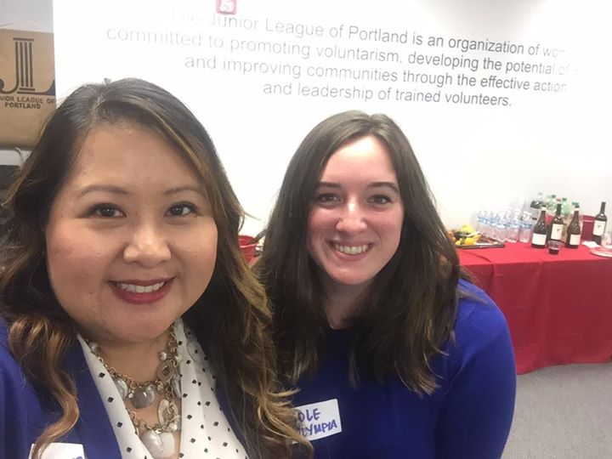
The Training Council met in July to work on amazing programming for the league year.
Contact Us
Junior league of olympia
108 State Ave. NW
Olympia, WA 98501
Telephone
Email
Website
Junior league of olympia
108 State Ave. NW
Olympia, WA 98501

Junior League Value Village Fundraiser, May 27, 2017

Chair and Chair-Elect Training, June 10, 2017

25th Anniversary Kickoff Event, Aug. 10, 2017
Northwest Exchange Olympia, March 9-11, 2018

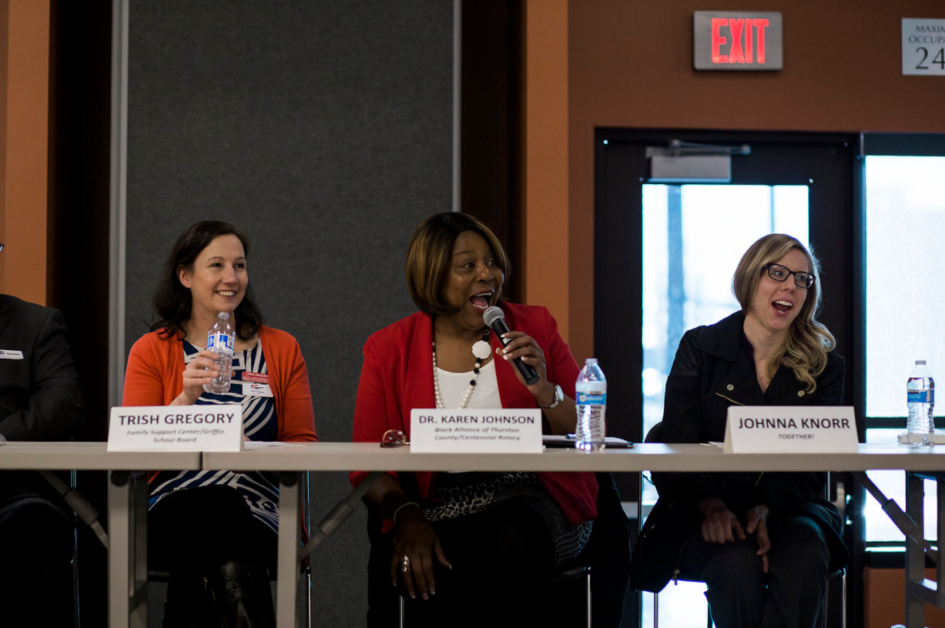
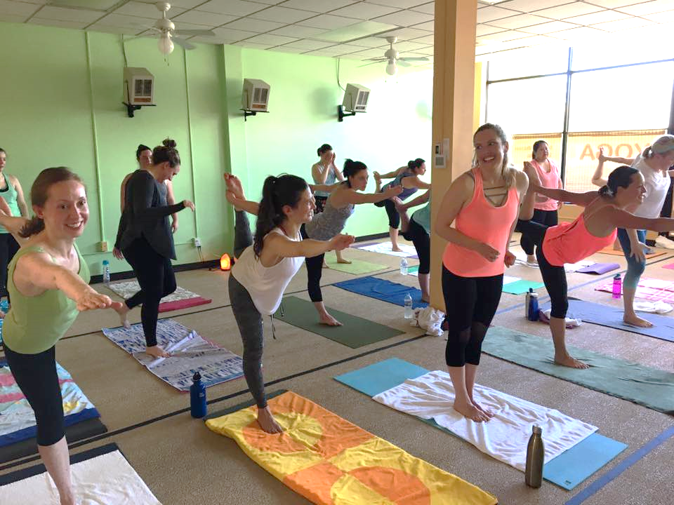
Kayleigh Stefanko Photography

